Parkville College FLC – Yard Duty and Supervision Policy

Purpose 2
Objective 2
Scope 2
Policy 2
Before and after school 2
Yard supervision 2
Sign In and Out process 3
Classroom Supervision 3
School activities, camps and excursions 4
Workplace learning programs 4
Students requiring additional supervision support 4
Communication 4
Policy evaluation and review 5

Purpose

The purpose of this policy is to explain to staff the Parkville College - FLC Campus yard duty procedures and expectations for the appropriate supervision of secondary students. Appropriate supervision is an important strategy to monitor student behaviour and enables staff to identify and respond to possible risks at school as they arise. It is also playing a vital role in helping schools to discharge their duty of care to students.

Objective
To ensure that school staff understand their supervision and yard duty responsibilities.

Scope
This policy applies to all teaching and non-teaching staff at Parkville College - FLC Campus, including education support staff, casual relief teachers and visiting teachers.

Policy
Appropriate supervision is an important strategy to monitor student behaviour and enables staff to identify and respond to possible risks at school as they arise. It also plays a vital role in helping schools to discharge their duty of care to students.

The Campus Principal is responsible for ensuring that there is a well organised and responsive system of supervision and yard duty in place during school hours, before and after school, and on school excursions and camps.

School staff are responsible for following reasonable and lawful instructions from the principal, including instructions to provide supervision to students at specific dates, time and places. Supervision should be undertaken in a way that identifies and mitigates risks to child safety.

Before and after school
The Parkville College - FLC Campus is supervised by school staff from 8.45am until 4.00pm. Outside of these hours, school staff will not be available to supervise students.
Students who may wish to attend school outside of these hours will be expected to sign in and out of the teacher office.

Yard supervision
This is a two storey leased premises and students only have access to the ground level. Parkville College - FLC Campus has a small outside courtyard area for students to take breaks. During break times students at this campus will stay on Parkville College - FLC Campus ground level or courtyard where there is a table and chairs. However, when students are not on the ground level (either on break or coming and going from school) then the following should be noted:
- Teachers and wellbeing staff monitor student breaks and follow up student absences immediately.
- Be alert and vigilant – intervene immediately if potentially dangerous behaviour is observed
- During transition times supervise students as they go to and from class
- Younger students, students with behavioural difficulties or students with disabilities require a greater level of supervision. These students will be supported according to a behaviour support plan that will be developed by their student support group.
- Always enact duty of care responsibilities even if the student isn’t in your allocated class group.
- Alert Campus Principal or coordinator if more supervision is required.

Map of 88 Kerr Street – Highlighted area indicates courtyard

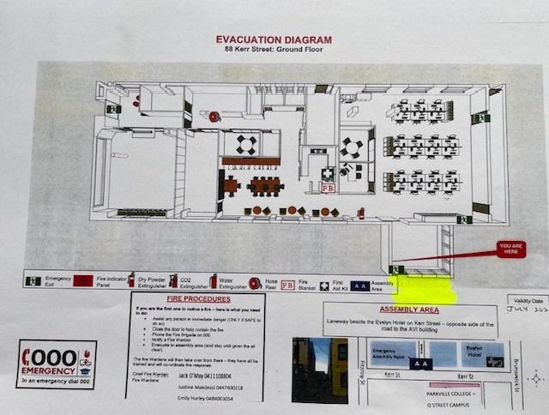

Sign In and Out process
All visitors to the Parkville College - FLC Campus will sign in and out at the teacher office. All visitors will read Child Safety Code of conduct when they sign in. If Working with Children’s Check is required, then the visitor will provide WWC details to school administration. Visitors will wear a bright orange lanyard and visitor pass whilst on site.

Classroom Supervision
Students at the Parkville College - FLC Campus will be supervised at all times by teachers and senior wellbeing workers. Every class is supported by a teacher or youth worker each of whom have a duty of care to the students in the class. However, the teacher in charge of the class should note that:
- It is NOT appropriate to leave students unsupervised in the care of unqualified ancillary staff, parents or trainee teachers
- It is NOT appropriate to leave students in the care of external education providers (for example incursions)
- If a student leaves the classroom during class (with or without permission) then allocated staff members will supervise the student until they return to class. If the student leaves school grounds then the student’s parent, guardian or carer will be informed immediately. If the student is in imminent danger (to self or others) the staff member will keep the student in line of sight if possible and call police and notify Principal.

School activities, camps and excursions
The Principal and Campus leadership team are responsible for ensuring that students are appropriately supervised during all school activities, camps and excursions, including when external providers are engaged to conduct part or all of the activity. Appropriate supervision will be planned for school activities, camps and excursions on an individual basis, depending on the activities to be undertaken and the level of potential risk involved, and will follow the supervision requirements in the Department of Education and Training Excursions Policy.

Workplace learning programs
When students are participating in workplace learning programs, such as work experience, school-based apprenticeships and traineeships, and structured workplace learning, the safety and welfare of the student is paramount. Organising staff are required to follow all applicable Department of Education and Training policies and guidelines in relation to off-site learning, including policy and guidelines on the safety and wellbeing of students. Refer to:
- Structure Workplace Learning
- School Based Apprenticeships and Traineeships
- Work Experience
- School Community Work

Students requiring additional supervision support
Sometimes students will require additional supervision, such as students with disability or other additional needs. In these cases, the Principal or delegate will ensure arrangements are made to roster additional staff as required. This may include on yard duty, in the classroom or during school activities.

Communication
This policy will be communicated to our school community in the following ways:

- Included in staff induction processes
- Discussed at staff briefings or meetings, as required
- Included in our staff handbook
- Included as a reference in our school newsletter each term
- Made available in hard copy from school administration upon request

Further Information and Resources
- the Department’s Policy and Advisory Library (PAL):
  - Child Safe Standards
  - Cybersafety and Responsible Use of Technologies
  - Duty of Care
  - Excursions
  - School Based Apprenticeships and Traineeships
  - School Community Work
  - Structured Workplace Learning
  - Supervision of Students
  - Visitors in Schools
  - Work Experience

Policy evaluation and review
This policy was last updated on June 2022 and is scheduled for review in June 2024.

