Parkville College Curriculum Framework and Time Allocation Policy

Contents
Parkville College Curriculum Framework and Time Allocation Policy 1
Purpose 2
Policy Statement 2
Guidelines 2
Implementation 2
Individual Education Plans (IEP) 2
Pedagogy 2
Curriculum 3
Curriculum Framework 5
Time Allocation per Learning Area 6
Relevant Legislation & Documents 7
Policy evaluation and review 7
Appendix 1 8
School Pedagogy 8
Appendix 2 9
Curriculum Plan including Time Allocations 9
All YJ Units Except Barnett 9
Barnett Unit Only 9
Secure Care Campuses 10

Purpose
In response to the diverse array of standards and abilities, Parkville College provides a flexible curriculum to meet our students’ diverse needs. This policy outlines the school’s framework for curriculum planning.

Policy Statement
The Curriculum Framework and Time Allocation policy is used to organise, implement and review curriculum delivery at Parkville College. Parkville College is committed to providing appropriate time allocation across all learning areas to ensure students receive a balanced education. In this policy, ‘curriculum’ refers to all arrangements the school makes for students’ development and learning. It includes the course content, student activities, teaching approaches, the way in which teachers and classes are organised and decisions on the need for and the use of facilities and resources. As with all our work at Parkville College, our curriculum is informed by the culturally responsive pedagogy outlined in The Parkville College Model (see appendix one).
Parkville College upholds the belief that ‘everyone has the right to education’ as stated within Article 26 of the International Declaration of Human Rights. Our mission is to provide every child in custody with a culturally safe and relevant education that is directed towards their full development and equips them to achieve their goals. To achieve this we provide a diverse and flexible curriculum that privileges student voice and promotes student agency.

Guidelines
Our school will recognise and respond to diverse student needs when developing its curriculum programs and Curriculum Plan.
Parkville College will comply with all Department of Education and Training (DET) guidelines about the length of student instruction time required in Victorian schools.

Implementation

Individual Education Plans (IEP)
Teachers work with Parkville College students to develop IEPs in accordance with DET policy and guidelines.
School curriculum programs will be designed to enhance effective learning. Preparing young people for the transition from school into further education and careers is a critical element of our curriculum programs.

Pedagogy
Teaching and learning at Parkville College are based on the foundational principles of unconditional positive regard and inclusive education. Trauma informed practice, attachment theory and culturally responsive teaching strongly informs our school wide pedagogy, outlined in ‘The Parkville College Model’. Our teaching focuses on the cultural safety and security of the student in a custodial environment that can be volatile, unstable and offer little to nourish secure relationships. In such an environment, we focus on co-creating culturally safe, consistent and secure attachments. Our teachers prioritise relationships and class content is driven by a culturally responsive curriculum that centres student voice.

Curriculum
Parkville College is registered with the Victorian Registration and Qualifications Authority (VRQA) as a senior secondary provider to deliver the Victorian Certificate of Education (VCE) and the Victorian Certificate of Applied Learning (VCAL) at Foundation, Intermediate and Senior levels. We have an auspice arrangement with Melbourne Polytechnic to deliver Vocational Education and Training (VET) certificates. Parkville College currently deliver units of competency from within the following certificates:
- Certificate II in Engineering
- Certificate II in Hospitality (Kitchen Operations)
- Certificate II in Visual Arts
- Certificate II in Music
- Certificate III in Music
- Certificate II in Fitness
- Certificate I in Construction
- Certificate II in Building and Construction (Carpentry) Pre-apprenticeship
- Certificate II in Building and Construction (Painting & Decorating)
- Certificate III in Warehousing Operations - Forklift
- Certificate II in Engineering
- Certificate II in Landscaping
- Certificate II in Community Services
- Certificate III in Hairdressing
- Certificate III in Fitness
- Certificate II in Landscaping
School curriculum and teaching practice is reviewed against the Framework for Improving of Student Outcomes (FISO). FISO and the FISO improvement cycle help identify focus areas for improvement and to evaluate the impact of introduced initiatives. This evaluation is completed through the Strategic Planning Online Tool (SPOT) and it directly influences school direction in the form of what goals are set in the School Strategic Plan (SSP) and Annual Implementation Plan (AIP).
Parkville College also reviews curriculum and teaching practice through additional embedded processes:
Professional Learning Communities (PLC)
Parkville College uses PLCs to create a culture that is:
- focussed on continuous improvement by linking the learning needs of students with the professional learning and practice of teachers
- committed to professionalism
- fuelled by collaborative expertise.
PLCs help our teachers to evaluate the effect of high impact teaching strategies as well as trialling new curriculum plans.
Performance and Development Plan (PDP)
The Performance and Development cycle is designed to:
- support Parkville College in meeting its responsibilities to students, parents and to government through linking employee performance with achievement of school and government policies and targets
- provide feedback on performance which will support ongoing learning and development of employees with a focus on ways in which student learning can be improved
- provide a supportive environment for improving teaching practice
PDP goals are directly aligned to the School Strategic Plan (SSP) and Annual Implementation Plan (AIP), ensuring that collective focus is on advancing common objectives. The PDP process involves a start-of-cycle, mid-cycle, and end-of-cycle review of every teacher, during which teachers have to demonstrate evidence of achievement in the focus areas.
Assessment
Parkville College assesses student progress in line with the Department’s Assessment of Student Achievement and Progress Foundation to 10 policy.
Students at Parkville College will have multiple and varied opportunities to demonstrate learning and achievement. Teachers use assessment tasks that cover multiple curriculum levels to ensure that evidence of learning and growth is captured for every student.
- Teachers at Parkville College use a combination of formative assessment for learning (to focus feedback and guide future learning) and summative assessment of learning (to determine what the student has learned at the end of a sequence of learning), alongside student self-assessment and reflection.
  - Formative Assessment: YARC, WIAT, Morrisby
  - Summative Assessment: Moderation processes. Continuum. Student Education Profile.
  - Self-Assessment and Reflection: Teacher to student ratio allows high number of 1-1 conversation on learning. Parent-Teacher Interviews, Student Conferences following SEP.
- Assessment is used in an ongoing way, to guide future lessons and learning, as well as to keep students and parents informed of student progress.
  - Assessment is regularly reviewed through
    - Professional Learning Communities
    - Leadership Supervision
    - High levels of reporting (In 2020-2021, once a Term; moving forward anticipating this will be twice a term, or linked to student time at College.
  - Assessment is made available to student and their parents/guardians through:
    - Calls home
    - Student Education Profile
    - Assessment Portfolio (TBC)
    - Moving forward: direct access to Compass.
- Teachers will use a variety of assessment strategies to gather evidence about student achievement. The agreed assessment processes and tasks are documented in the Subject Unit Designs and Learning Sequences. The assessments may include, but are not limited to, tests and assignments, projects, portfolios, performances, discussions or student-teacher conferences.
- Assessment tasks are developed to support students to show their knowledge, skills and understandings and will include clear instructions, relevant supporting documents (scaffolds, planning documents, etc) and allow sufficient time for completion. Teachers will make modifications to the task to cater for students with additional learning needs.
- Parkville College will develop Individual Education Plans (IEPs) for all of our students (*for the YJ Campuses this is completed for students who have been at the school for 14 days or more, for the Secure Care and FLC Campuses, these are completed for all students). The breadth of the plan is linked to the length of stay at Parkville College. The school has avenues to connect with community school to ensure they have an IEP prepared for their students upon returning to school.
- Where possible, staff will participate in cross marking of assessment tasks (moderation) involving assessment rubrics and work samples so that staff can apply consistent judgements of student progress against Victorian Curriculum Standards across the school.
Reporting
At Parkville College Student Students receive a Report at least once a Term. Reports are produced in conjunction with students. Reporting at Parkville College reflects the context that our students are in, and is shaped by the amount of time they have spent with the college, i.e:
- Students in Secure Care receive a Student Report within the duration of their (maximum) 21 day stay (average 5 days).
- Students within the youth justice custodial settings receive a Student Education Profile at least once a Term, with increasing detail, based on their length of stay.
- Students at the Flexible Learning Centre receive a weekly updated IEP and a Termly Student Report.
Parkville College reports student progress to ensure that there is continuous sharing of assessment information formally and informally with parents/carers throughout the term/semester, including through twice-annual formal reporting.
The report will be in a written format easy for parents/carers to understand and will be accessible in digital form with the option to translate text from English to another language, to cater to our school community.
- Both student achievement and progress will be included in the report.
- Opportunities will be provided for parents/carers and students to discuss the school report with teachers and/or school leaders.
Parent-teacher interviews enable the opportunity to discuss the students’ progress and how they can continue to be supported at home. Interpreting services will be made available for where required.

Curriculum Framework
Curriculum will be planned within teams. VCAL, VET and VCE student outcomes will be internally and externally moderated in accordance with VCAA regulations.
There will be a broad offering of programs to meet the diverse needs of our students. VCAL will be offered, together with Vocational Education and Training (VET) courses.
Single VCE units and full VCE will also offered through the Virtual Schools Victoria (VSV). Enrolment in VCE will be undertaken with consideration for whether a student is likely to remain at Parkville College long enough to complete an entire VCE Unit, and whether a student is committed to completing all the work requirements of the VCE Unit. Consideration must also be given to the practicalities of undertaking study in the particular subject area in a custodial setting. Single VCE subjects may also be undertaken through VSV if a student has a particular area of interest and talent that Parkville College is unable to offer.
VET courses will be offered in accordance with student interest and in order to provide a practical focus in a range of industry areas. VET courses enable students to undertake nationally recognised training that contributes to their VCE or VCAL.
Parkville College will provide a variety of programs that will address the specific needs of students. Within learning areas, teachers have discretion to work towards student interests and needs.
When developing its Curriculum Plan, our school will provide at least 25 hours of student instruction per week, and will generally provide significantly more than 25 hours.
Input will be sought from teaching staff when determining programs for the following school year.
The DET requirements related to the teaching of Physical Education, Sports Education and EAL (where appropriate) will continue to be implemented.
The use of Information and Communications Technology (ICT) will be integrated across the curriculum to support the improvement of teaching and learning outcomes. However the use of ICT will be restricted by the parameters set by DJCS/DFFH Operations Manuals.
In developing its curriculum plan the school will provide a broad range of educational pathways to ensure improved student outcomes.

Victorian Certificate of Applied Learning (VCAL)
The VCAL is centred on the development of knowledge and employability skills that help prepare students for work and participation in a broader society, family and communities. The program assists students to make informed vocational choices, facilitating pathways to further learning and employment. Students who undertake the VCAL become more independent and responsible for their own learning and improve their motivation and commitment to their education.

Vocational Education and Training (VET)
Vocational Education and Training (VET) provides students with the necessary skills and experience to prepare for employment and further training. VET subjects and units offered at Parkville College are fully accredited through Melbourne Polytechnic. Melbourne Polytechnic has been delivering practical and professional education Melbourne’s northern suburbs for over 100 years.

Time Allocation per Learning Area
Parkville College delivers 6 hours of educational programs, 6 days a week and works across 52 weeks of the year.

VCAL
At Parkville College, the VCAL learning program will be delivered in accordance with VCAA with each of the three VCAL award levels including a nominal duration of 1000 hours, including a mix of class time and independent learning. However, the nominal hours (including both scheduled and unscheduled contact hours) may vary when considering the specific needs of each student. Attendance in a school setting will be determined by the Education Training and Reform Act (ETRA), which stipulates that every student must attain 25 hours of face-to-face tuition weekly until the age of 18, and free access be open to students until the age of 21. This minimum of 1000 hours will be shared across all of the VCAL, VCE and VET Learning Areas. The Curriculum Plan set out in Appendix Two stipulates the weekly time allocation for each learning area.
In some special circumstances the face-to-face teaching hours may vary. Parkville College will take into consideration the specific needs of each student, and attempt to provide an optimal learning environment that suits individual needs. As outlined by DET, this will work alongside a child’s IEP.

VCE
Parkville College currently has the capacity to deliver units 1 and 2 of Legal Studies, and Unit 1 and 2 of Philosophy. Parkville College staff support students with managing their allocated time toward the completion of individual VCE subjects.

Relevant Legislation & Documents
Department of Education and Training (DET):
- Education and Training Reform Act 2006
- Individual Education Plans Policy
Victorian Curriculum and Assessment Authority (VCAA):
- VCE English and English as an Additional Language (EAL) Text List 2017
- VCAA Victorian Curriculum F-10
- VCAA - VCAL Unit Assessment Planning Guide
- VCAA The Curriculum Planning Resource

Policy evaluation and review
To ensure ongoing relevance and continuous improvement, this policy will be reviewed every 3 years.
This policy was last updated on September 2021 and is scheduled for review in September 2024.

Appendix 1

School Pedagogy
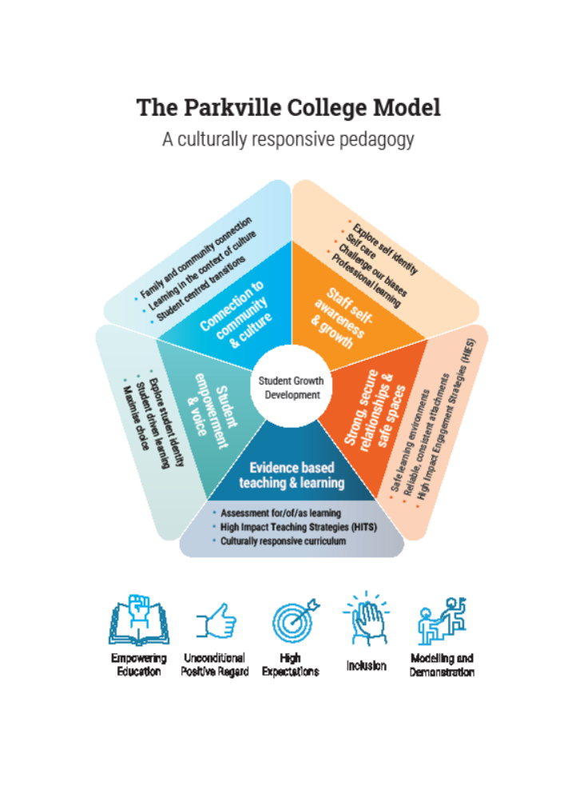
Appendix 2

Curriculum Plan including Time Allocations

All YJ Units Except Barnett
Learning area | Time allocation per week
Literacy | 10 hours
Numeracy | 5 hours
Physical & Sports Education | 7 hours
Personal Development Skills | 4 hours
A selection of:  Landscaping  Kitchen Operations/Hospitality  Hairdressing  Personal Training  Music  Art  Media  Community Services  Building & Construction  Engineering | 12 hours total
Total per week | 38 hours

Barnett Unit Only
Learning area | Time allocation per week
English and Studies of Society and the Environment | 10 hours
Maths and Science | 5 hours
Physical & Sports Education | 7 hours
Personal Development Skills | 4 hours
A selection of:  Technology  Landscaping  Hospitality  Music  Art | 12 hours total
Total per week | 38 hours

Secure Care Campuses
Learning area | Time allocation per week
English and Studies of Society and the Environment | 10 hours
Maths and Science | 5 hours
Physical & Sports Education | 7 hours
Personal Development Skills | 4 hours
A selection of:  Technology  Landscaping  Hospitality  Music  Art | 12 hours total
Total per week | 38 hours

